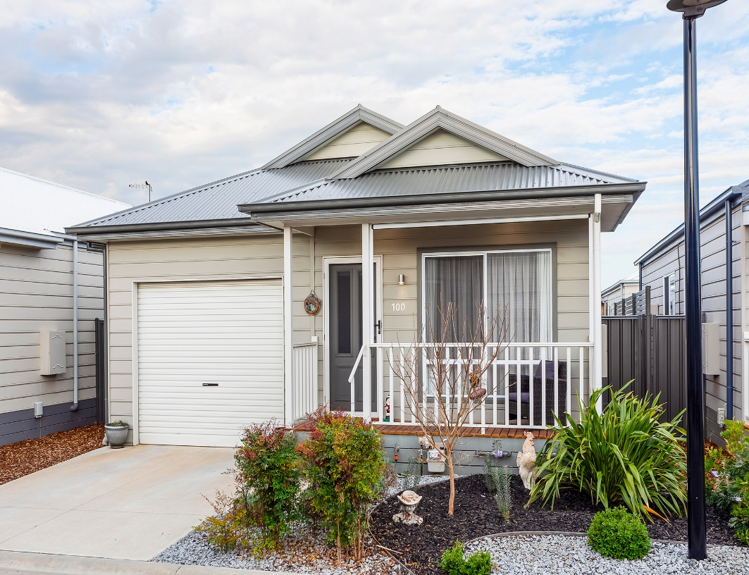

Cumberland

100/114 RIX ROAD, OFFICER

Offers above $375,000



**Framed by a verandah that overlooks a landscaped garden, this two bedroom home cleverly separates living and dining zones in our lovely Officer Community. Features of this home is a modern kitchen with stone benchtops, stainless steel appliances and soft close drawers. The two spacious bedrooms come with built in mirrored robes and located between the bedrooms is a contemporary bathroom. This home comes with a reverse cycle split system heating and cooling. Step outside to a gorgeous undercover outdoor alfresco area with large fan and enclosed with PVC blinds.**

**Don’t wait, call now to inspect!**

2

2

1

1.5



Offers above $375,000

Cumberland

100/114 RIX ROAD, OFFICER